

GRADE 11
JULY EXAMINATION 2013
HISTORY
PAPER 1 (ESSAY PAPER)
2 hours 100 marks

INSTRUCTIONS:
- This paper consists of 6 pages plus a Source Booklet of 3 pages
- There are TWO sections in this exam
- SECTION A – Question 1-Discursive Essay (70)
- SECTION B – Question 2-Extended Writing (30)
- You are to answer all the questions in the book provided.
- Make sure your answers are correctly numbered and clearly written. Write on both sides of the page.
- Accurate and adequate factual knowledge is essential; equally important in answering the questions is the ability to use relevant information critically.
- Time yourself and do not spend too much time on one question and too little on another.
- When you have finished your exam put your question paper at the back of the answer book.

EXAMINER: MRS J-A MOGG MODERATOR: MRS A LOURENCO

SECTION A – DISCURSIVE ESSAY
QUESTION 1
The following essay is a discussion essay and you are expected to use interpretation, analysis, explanation and argument.
“The Uprising of 1984 had almost no effect on the National Party government and had very little to do with the end of apartheid in South Africa.’

Decide on the accuracy of this statement, and support your response by putting the Uprising in its social and political context.

70 marks

SECTION B – EXTENDED WRITING
QUESTION 2
Your answers must show evidence of historical knowledge and understanding.

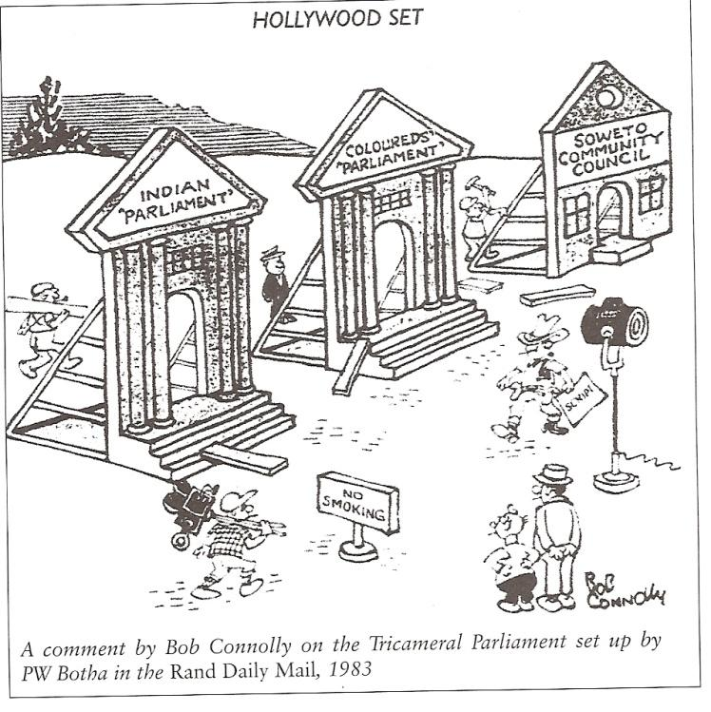
To what extent were PW Botha’s reforms cosmetic and ineffectual?
Use the following as a guide to help you answer the question:
- What was the Tri-cameral Parliament and why was it rejected by the majority of the population?

- What other reforms did Botha introduce and why were they regarded as cosmetic?

30 marks

